ILMA CMS
Developer / Architecture Document
Full-system module map: roles, data model (ERD), workflows, interconnections, automation and bulk-import surface
Companion to: ILMA Self-Hosted Chat Architecture · Around Final Payment · Results & Analysis Architecture

1. Purpose & Scope
This document is the single connected architecture reference for ILMA CMS: how every role, module, workflow and automation rule fits together end to end — from bulk data entering the system to what each role sees on their Dashboard and Settings screens. It is meant to be the starting reference for MVP build-out, not a feature wishlist.
It covers, in one pass:
- Roles — the permission backbone every other module hangs off
- The full data model as an Entity-Relationship Diagram (ERD)
- Module-by-module workflows: Attendance, Timetable & Substitute Allocation, Results, Bulk Data, Backup, Dashboard, Settings
- Which workflows are interconnected (share data/trigger each other) vs. genuinely independent
- A complete automation registry — every rule that fires without a human clicking a button
- The bulk-import surface — every entity that can be mass-uploaded through one reusable engine
Three companion documents already scoped in detail are referenced rather than repeated in full: Self-Hosted Chat Architecture (messaging/permissions for parent-teacher channels), Around Final Payment (large-payment routing via 1BILL/Raast), and Results & Analysis Architecture (the charting/analytics stack). See Section 12.

2. Roles — The Backbone Everything Else Attaches To
Every module below is gated by role. Two structural rules apply everywhere and are not repeated per module:
- Every role gets its own Dashboard composition and its own scoped slice of Settings — Super Admin gets system-wide settings, everyone else gets settings scoped to their own role/data.
- Role and relationship checks (which parent belongs to which student, which teacher teaches which section) live in ILMA's own data model — every module trusts this same source of truth rather than re-implementing access logic.
Role | Scope
Super Admin | Institute owner / platform level — sees everything, controls subscription/billing, system-wide settings, backups, security; can override any other role's action.
Admin / Principal | Day-to-day operations — staff, students, fee config, result approval, announcements, substitute decisions.
Coordinator / HoD (optional tier) | Same authority as Admin, scoped to one department/wing — useful for larger institutes.
Class / Subject Teacher | Attendance marking, result upload, homework, messaging, own timetable.
Accountant / Front Desk | Cash collection, invoice reconciliation.
HR / Admin Staff | Staff records, leave approvals, attendance oversight.
Librarian, Transport Coordinator | Module-scoped roles, limited to their own domain.
Student | Own timetable, results, homework, notices.
Parent | Child's attendance, fees, results, announcements, teacher messages.

3. System Data Model (Entity-Relationship Diagram)
This is the shared schema every module below reads from and writes to. It is grouped by domain — organization/access, people, academic structure, day-to-day operations, results, finance and communication — but every table is one connected database, which is what makes the Dashboard a pure read layer (Section 9) rather than a separate data silo.
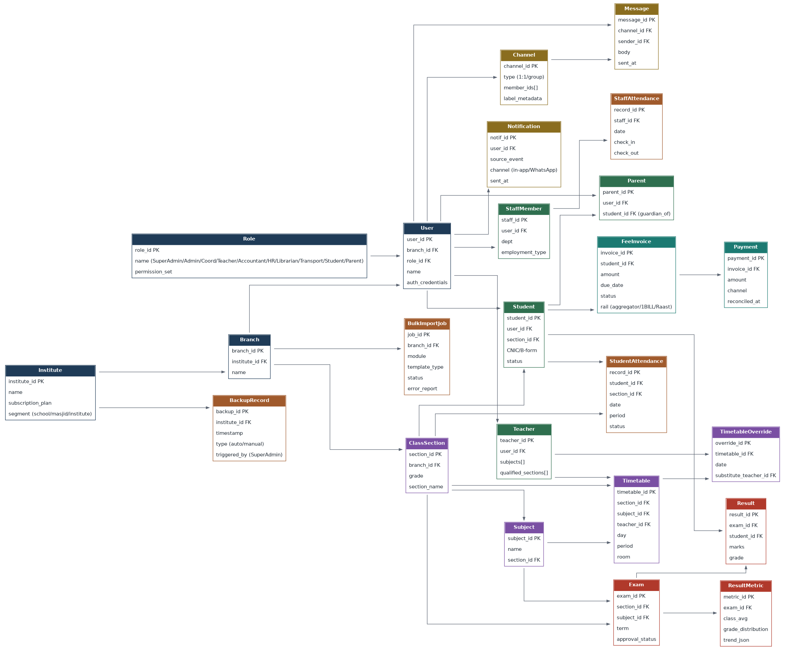
Figure 1 — Core ERD. FK = foreign key. Arrows point from the referenced (parent) entity to the dependent (child) entity.

Reading the diagram
- Institute → Branch → User is the tenancy chain: every institute can have multiple branches, and every login belongs to exactly one branch and one Role.
- Student / Parent / Teacher / StaffMember are all thin role-specific profiles hanging off the same User record — one identity system, not five.
- ClassSection is the hub for academic structure: Subject, Timetable, StudentAttendance and Exam all key off it.
- TimetableOverride never edits Timetable directly — see Section 5 for why that separation matters operationally.
- Result and ResultMetric are deliberately separate: Result is one row per student per exam (raw), ResultMetric is the pre-computed, cached aggregate the charts read (Section 6).

4. Attendance — Two Independent Layers, One Combined View
This module is the clearest example in ILMA of the interconnected-vs-not distinction that runs through the whole system: two data models that never touch each other directly, aggregated into one dashboard view.

4.1 Layer 1 — Class/Period-Level Attendance
- Subject or class teacher marks present/absent per period (or once daily for younger grades).
- Writes to the StudentAttendance record — scoped to student + section + date + period.

4.2 Layer 2 — Staff Attendance
- A separate table, marked via check-in/checkout (manual, QR, or biometric integration later).
- Independent of student attendance — it does not share a data model with it.

4.3 Where They Connect
A nightly / real-time aggregation job rolls up (a) every class's attendance % into a school-wide student attendance %, and (b) staff check-ins into a school-wide staff attendance %, and displays both as one combined card on the Admin/Super Admin dashboard, with drill-down into any single class or department.
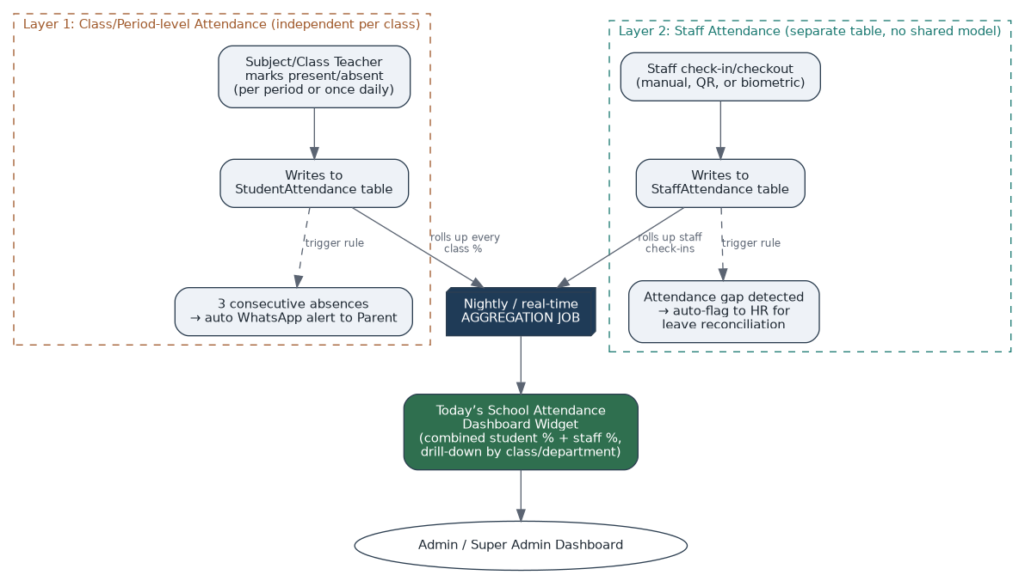
Figure 2 — Attendance data flow: two independent layers feeding one aggregation job.

4.4 Automation on This Module
- 3 consecutive student absences auto-triggers a WhatsApp alert to the parent — consistent with the message-routing principle from the Chat Architecture doc: daily single absences stay on free CMS push, only the escalated multi-day case earns a paid WhatsApp send.
- Staff attendance gaps auto-flag to HR for leave reconciliation.

5. Timetable, Sync & Substitute Allocation

5.1 Base Timetable & Clash Detection
- Built once by Admin/Coordinator: a subject × period × class × teacher × room grid.
- Automatic clash detection at creation time — the system refuses to assign a teacher to two classes in the same period, or two classes into the same room simultaneously.

5.2 Sync — One Master Grid, Filtered Views
- Each teacher's personal dashboard shows only their own day's schedule — a filtered view of the master timetable, not a separate copy.
- Parents/students see their child's/own daily schedule the same way.
- Optional: push a teacher's personal schedule to their own Google Calendar.

5.3 Substitute Allocation Workflow
This is the specific mechanism requested: at the moment a teacher goes absent, the system suggests — it never decides — who should cover each vacant period.
- Teacher marks themselves absent/on-leave for a date, via the Staff Attendance/Leave module.
- System looks up every period that teacher was scheduled to teach that day.
- For each vacant period, it cross-references every other teacher's timetable at that exact slot and filters to those with no class scheduled — i.e., genuinely free.
- It ranks that free list (same-subject-qualified teachers first, if that refinement is enabled) and presents it to Admin/Super Admin as suggestions, not an automatic decision.
- Admin picks one substitute per vacant period.
- System writes a temporary override into that day's timetable — the base timetable itself is untouched.
- Notifies the assigned substitute (in-app/push) and updates the affected class's daily view.
- Logged separately for a substitution-frequency report (useful later for HR/workload review).
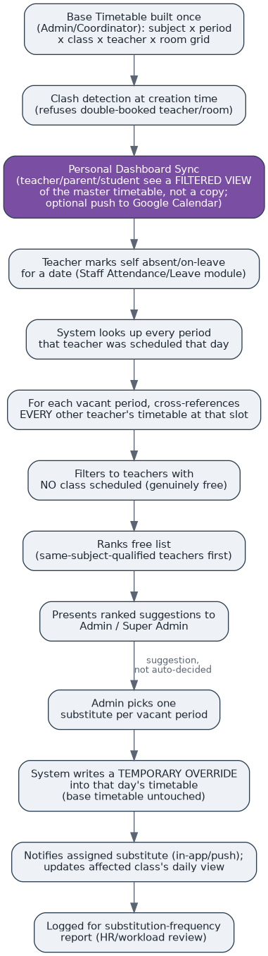
Figure 3 — Substitute allocation: the free-teacher lookup runs against the live timetable, and the base grid is never mutated directly.

6. Results & Analysis
End-to-end path from a teacher's upload to a parent's notification and the analytics layer. The computation/visualization stack (pandas/danfo.js + Apache ECharts, and why a generic BI platform like Superset/Metabase was rejected) is scoped in full in the companion Results & Analysis Architecture document — this section covers the workflow around it.
- Teacher enters marks — either manually per student, or via bulk upload (a marks-sheet Excel template per class/subject/exam, through the same Bulk Import Engine in Section 7).
- Optional approval gate, configurable per institute: for internal quizzes, auto-publish immediately; for term/final results, route through Admin/Coordinator sign-off before release — this catches entry errors before they reach a parent.
- On publish, the result writes directly to the Results Portal (the student/parent-facing view) — no separate manual step.
- Notification fires automatically: in-app for routine tests, WhatsApp for major term results — the same cost-tiered routing principle used for attendance alerts.
- Result data also feeds the analytics layer — class average, subject-wise trend, a student's performance-over-time chart — visible on Admin and Teacher dashboards.
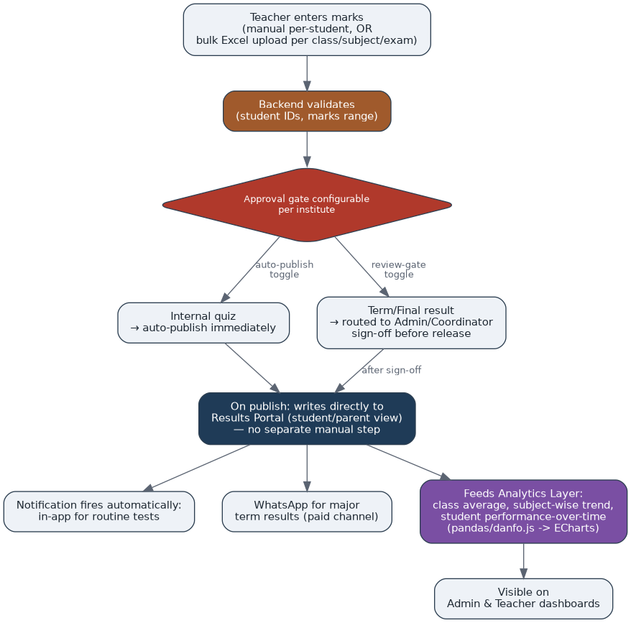
Figure 4 — Results pipeline: entry -> validation -> configurable approval gate -> portal + notification + analytics, in one publish action.

7. Bulk Data — One Reusable Engine
Rather than building bulk-upload separately for every module, ILMA uses one generic Bulk Import Engine, reused everywhere the same shape of problem shows up: turning a spreadsheet into validated, committed records.
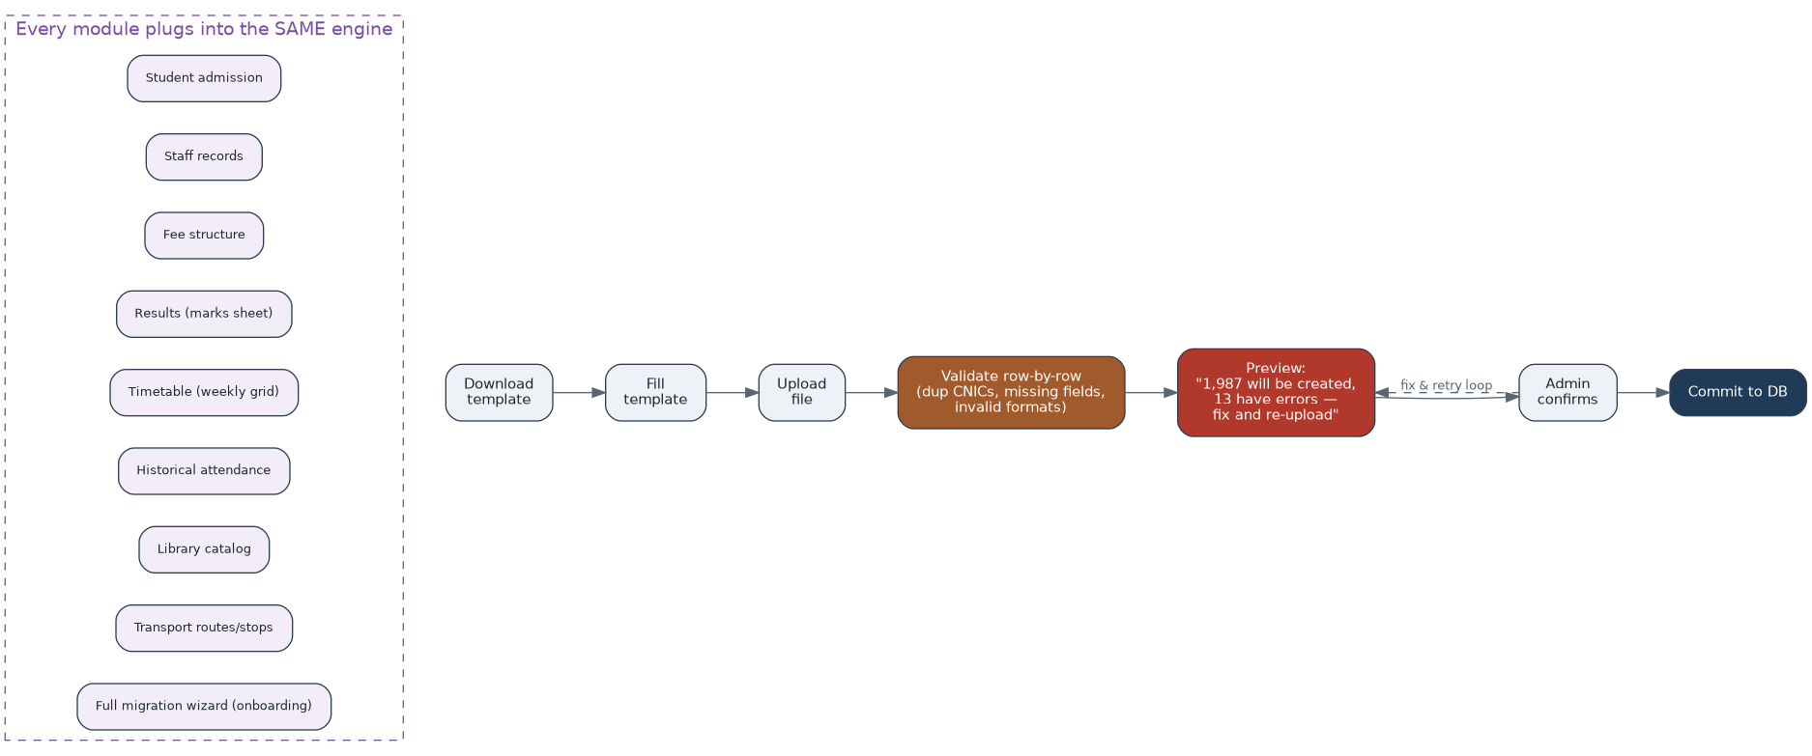
Figure 5 — The Bulk Import Engine: one pipeline, plugged into by every module on the left.

7.1 Modules That Plug Into It
Module | What gets bulk-imported
Admissions | Enroll a whole class/section from a spreadsheet
Staff | Staff records
Fees | Fee structure — fee heads per class
Results | Marks sheet, per class/subject/exam
Timetable | Weekly grid import, for large schools instead of manual grid-building
Attendance | Historical attendance, migrating off an old system
Library | Library catalog
Transport | Transport routes/stops
Onboarding | One-time full data-migration wizard from whatever system the institute used before

7.2 The Pipeline, Every Time
Download template -> fill it -> upload -> system validates row-by-row (flags duplicate CNICs, missing required fields, invalid formats) -> shows a preview ("1,987 will be created, 13 have errors — fix and re-upload") -> admin confirms -> commit.

8. Backup
- Automated nightly backups with a retention policy (e.g., daily kept 30 days, weekly kept 6 months), stored off-site, with integrity checks.
- Super Admin only — this deliberately sits outside even Admin's reach, so a compromised or careless admin account can't touch backup/restore.
- Manual "Backup Now" trigger available before major changes (e.g., before a bulk import).
- Every restore action is itself logged and requires Super Admin confirmation.

9. Dashboard — Where Every Module Surfaces, Role by Role
The Dashboard is not a separate module with its own data — it is a read layer that queries the same underlying attendance, fee, results and timetable tables everything else writes to. That is what makes it reflect reality automatically rather than needing manual updates.
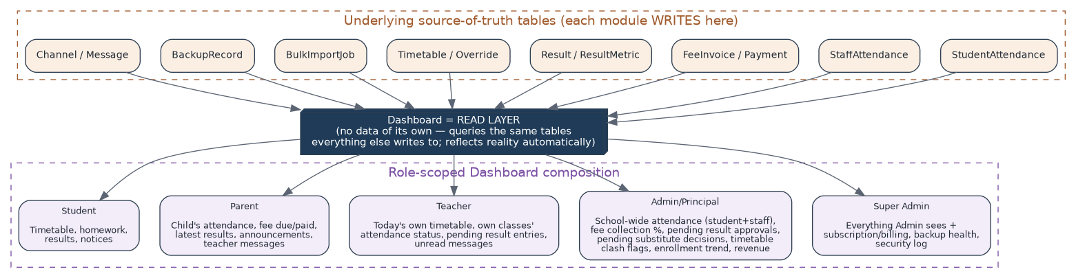
Figure 6 — The Dashboard reads from every module's source-of-truth tables and composes a role-scoped view; it never owns data.
Role | What their Dashboard shows
Super Admin | Everything Admin sees, plus subscription/billing status, backup health, security log.
Admin / Principal | School-wide attendance (students + staff combined), fee collection %, pending result approvals, pending substitute decisions, timetable clash flags, enrollment trend, revenue snapshot.
Teacher | Today's own timetable, their classes' attendance status, pending result entries, unread messages.
Parent | Child's attendance, fee due/paid status, latest results, announcements, teacher messages.
Student | Timetable, homework, results, notices.

10. Settings — Split by Scope, Not Duplicated
Scope | Contains
Super Admin settings | Subscription/billing, backup schedule, security/audit log, WhatsApp/Meta API credentials, global notification thresholds (e.g. "how many absences before auto-alert").
Admin settings | Fee structure, academic calendar, result-approval toggle (auto-publish vs. review-gate), announcement templates.
Teacher / Parent / Student settings | Personal — notification channel preference, language, profile.

11. Cross-Module Interconnection Map
A quick reference for what genuinely shares data or triggers another module automatically, versus what only looks related but is actually independent underneath.
Connected (shares data / triggers automatically) | Independent (separate model, no automatic link)
Class attendance + staff attendance -> "Today's School Attendance" aggregation widget | Class attendance data model vs. staff attendance data model (rolled up, never merged at the row level)
Results publish -> Results Portal write + notification + analytics layer, in one action | Internal-quiz publish rule vs. term-result approval rule (different gates, same pipeline)
Substitute allocation -> live Timetable lookup + TimetableOverride write | TimetableOverride vs. base Timetable (override never mutates the base grid)
Every module's writes -> Dashboard read layer (auto-reflects reality) | Dashboard itself vs. any module (it owns no data of its own)
3 consecutive absences -> WhatsApp parent alert; low attendance -> HR flag | Single daily absence (stays on free in-app push, no escalation)
Fee collection (Leg 1) -> automated disbursement (Leg 2) via webhook, per the Mantiq routing pattern reused where ILMA needs payout-on-behalf-of | 1BILL / Raast collection rail vs. aggregator card checkout (different rails by payment size, Section 12)
Bulk Import Engine -> every module's commit path (Section 7) | Backup/restore (Super-Admin-only, deliberately walled off from every other role's actions)

12. Companion Architecture Documents
Three areas of ILMA are scoped in full detail in their own standalone documents. They are referenced here rather than duplicated:

12.1 Messaging — Self-Hosted Chat Architecture
- Rocket.Chat Community Edition recommended over Matrix as the more turnkey starting point (built-in admin console, push notifications, conventional REST API) for production scale (50,000+ MAU).
- All channels are created server-side by the CMS backend — never directly by clients — so every channel is guaranteed to match the role-based permission matrix (Student<->classmates/teachers/admins, Parent<->child's teachers/admins/finance, Teacher<->parents of their students + admins + super admin, etc.).
- Parent<->teacher channels are relabeled per viewer: the teacher sees the channel headed by the student's name/section/photo, not the parent's own name — a display-layer decision only; the underlying channel is one real thread between two accounts.

12.2 Payments — Around Final Payment
- Aggregator card checkout (2-2.9%) stays for small, routine payments (monthly tuition, canteen top-ups) — the flat rupee cost is negligible and convenience matters more than the rate.
- A fourth payment flow is added for large payments above a school-configured threshold (admission fee, annual fee, security deposit): a 1BILL consumer number/QR is generated instead of an aggregator link — flat or near-flat cost regardless of amount.
- The reconciliation feed from 1BILL routes into the same auto-mark-paid logic the CMS already uses for webhooks, so large payments settle exactly as automatically as small ones.

12.3 Analytics — Results & Analysis Architecture
- Computation layer (pandas/danfo.js) turns raw uploaded marks into grade distributions, averages and percentiles; visualization layer (Apache ECharts) renders them — a generic BI platform (Superset/Metabase) was evaluated and rejected as the wrong tool for embedding branded, per-teacher/per-class charts inside ILMA's own UI.
- Computed metrics are cached as pre-aggregated JSON per exam + class + subject, so charts don't recompute on every page view — this is the ResultMetric entity in the ERD (Section 3).

13. Automation Registry
Every rule in ILMA that fires without a human clicking a button, gathered in one place.
Trigger | Automated action
3 consecutive student absences | WhatsApp alert to parent
Single daily absence | Free in-app/push notification only (no WhatsApp cost)
Staff attendance gap | Auto-flag to HR for leave reconciliation
Teacher marked absent for a date | System generates ranked substitute suggestions for Admin to pick from
Substitute confirmed by Admin | Temporary timetable override written; substitute notified; affected class view updated
Two teachers/rooms clash at timetable creation | Assignment refused at creation time
Result published (internal quiz) | Auto-publish immediately; in-app notification; analytics recomputed
Result published (term/final) | Routed to Admin/Coordinator sign-off first; WhatsApp notification on release
Payment above school-set threshold | Routed to 1BILL/Raast flat-fee rail instead of percentage aggregator link
1BILL/webhook reconciliation received | Invoice auto-marked paid
Nightly | Full system backup (retention policy applied); attendance aggregation job runs
Before a bulk import | Manual "Backup Now" available on demand
Fee due date approaching | Fee reminder sent
Library book overdue | Overdue reminder sent
Staff leave taken | Leave-balance recalculated
1st of each month | Auto-generated attendance/fee/performance reports delivered to Admin
Student birthday / school event | Greeting sent (free CMS push)
Admission/renewal deadline approaching | Reminder sent

14. Suggested Build Phases
Phase | Scope
Phase 1 — Core backbone | Roles/auth, Institute/Branch/User model, ClassSection/Subject, base Timetable with clash detection, Student/Staff records.
Phase 2 — Daily operations | Class + staff attendance (two layers), attendance aggregation widget, Bulk Import Engine (admissions + staff first).
Phase 3 — Results | Marks entry (manual + bulk), approval gate, Results Portal, notification routing, Teacher-facing charts.
Phase 4 — Substitute & Dashboard | Substitute allocation workflow, role-scoped Dashboards as the read layer over everything built so far.
Phase 5 — Finance & Messaging | Fee/invoice + payment rails (aggregator + 1BILL/Raast per Around Final Payment), self-hosted chat per Chat Architecture doc.
Phase 6 — Hardening | Backup/restore, Settings screens per role, full automation registry (Section 13), Student/Parent-facing analytics.

15. Open Questions
- Coordinator/HoD tier — build in MVP, or defer until a multi-branch institute actually asks for it?
- Same-subject-qualified ranking for substitute suggestions — enabled by default, or an institute-level toggle?
- Result recompute on correction — automatic recalculation of cached metrics, or an explicit "recalculate" action?
- Backup retention windows — confirm the default (e.g. daily x 30 days, weekly x 6 months) against actual storage cost at scale.
- Federation for chat (institutions running their own separate servers) — needed at MVP, or single centrally-hosted instance sufficient for the first cohort?
- Which PSP/aggregator for 1BILL — fast path via an existing reseller, or apply to 1LINK directly once enough schools justify the effort?

